Under the Auspices:
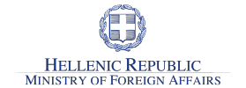
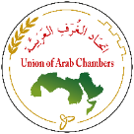
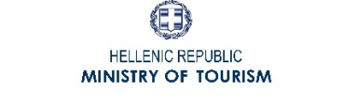
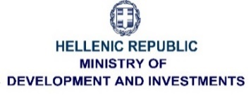

General Outlook:

The convening of the “8th Arab - Hellenic Economic Forum” on 27-28 November 2019 has a specific significance, as it coincides with the 40th anniversary of the establishment of the Arab-Hellenic Chamber, but also with the new wave of optimism and prospect for economic growth and development of Greece that has recently overcome the long financial crisis. The frequent visits between Arab and Greek businessmen, as well as the foreign direct investment and flow of tourism, along with the interest shown by the Arab investors in the real estate sector, are all encouraging indications of much anticipated economic growth. Last but not least, the increase in the trade balance between Greece and the Arab world is yet another sign of closer business relation.
We, at the Chamber, continuously strive to create new dynamics in our Forums, by carefully selecting topics of interest. This Forum falls in line with our objectives, as it will tackle plans for reconstruction and modernization of infrastructure in Syria, Iraq, Libya and Yemen. In addition, the focus will be given to sectors of maritime, port industries and real estate. These topics go along with the current affair of interest between the two sides.
Moreover, this Forum will add new dimensions by presenting successful entrepreneurs from Greece and the Arab world, as well as business women to support the increasing urgency to integrate female workforce in all business sectors, so the private sector can accelerate the work done by governments and communities. All these topics will be addressed and presented by key decision makers and relevant experts.
In view of the significance of this event, preparations are underway to ensure distinguished and diverse participations of businessmen from across the Arab world. As in all our events, we look forward to creating dynamics of active deliberation and networking, which will be enhanced by the arrangement of direct meetings between the two sides in all business domains.

Level of Participation:
Ministers and high-ranking Government officials, Arab Ambassadors and Presidents of Federations and Chambers of Commerce in the Arab world, Members of the Arab-Hellenic Chamber. High-ranking professionals from the Maritime and Port industries, top executives in the reconstruction process and modernization of infrastructure in the Arab world, active participation of business women entrepreneurs from both sides.

Speakers:
CEO’s and high-level Executives, young entrepreneurs from Greece and the Arab world.

Strategic Focal Points:
- Maritime Development, Opportunities and Future Potential
- Port Development & Plans for investment in Greece & the Arab World
- Women Empowerment in the Workforce, Start-Up Businesses, Success Stories & Opportunities for Partnership between Greek and Arab Entrepreneurs
- Open Session & Plenary Discussion
- Reconstruction Projects and Modernization of Infrastructure in countries affected by war in Iraq, Libya, Syria and Yemen - Potential & Opportunities
- Future Prospects on Tourism and Investment opportunities in the Greek Real Estate Market

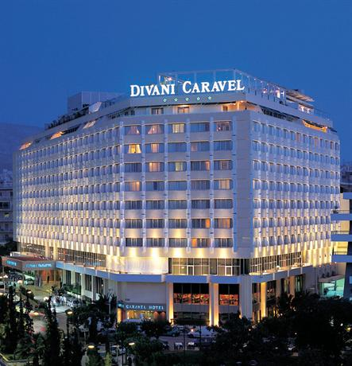
Venue:
Divani Caravel Hotel (5-star hotel) https://divanicaravelhotel.com/

Working Languages:
Greek and Arabic (with simultaneous interpreting)

Media Coverage:
Greek official TV, Arab media (Al-Ahram and Al-Sharq Al-Awsat) and reporters of satellite TV channels operating in Greece.

Forum’s Publications (in English language):
- Forum’s Main Brochure
- Special Edition of the Members’ Activities Newsletter

PRELIMINARY PROGRAM

Wednesday, 27 November, 2019
10:00-11:00 Registration & Coffee
11:00-11:30 Opening Ceremony
11:30-12:45 Session 1 “Maritime Development, Opportunities & Future Potential”
12:45-14:00 Session 2: “Port Development & Plans for Investment in Greece and
the Arab World”
14:00-14:45 Finger Food & Networking
14:45-16:00 Session 3: “Women Empowerment in the Workforce, Start-Up Businesses, Success
Stories & Opportunities for Partnership between Greek & Arab Entrepreneurs”
16:00-17:30 Open Session & Plenary Discussion

Thursday, 28 November, 2019
09:00 Registration & Coffee
09:30 Introduction of Sectors for the B2B meetings by the Arab delegates
09:45-11:15 Session 4: “Re-Construction Projects & Modernization of Infrastructure in
Countries affected by war in Iraq, Libya, Syria & Yemen – Potential & opportunities”
11:15-11:45 Coffee Break & Networking
11:45-13:00 Session 5: “Future Prospects on Tourism & Investment Opportunities
in the Greek Real Estate Market”
13:00-14:00 Enhanced Coffee Break & Networking
14:00-16:00 B2B meetings between the Arab Businessmen with their Greek Counterparts in all business sectors
16:00 End of Forum’s Works

Evening Program: Celebrating the “40th Anniversary of the Establishment of the Arab-
Hellenic Chamber of Commerce & Development”

19:30 Arrival of Guests, welcome drinks
20:00 Welcome address – Arab Hellenic Chamber
20:10 Speech by the Guest of Honour, the Prime Minister of the Hellenic Republic
H.E. Mr. Kyriakos Mitsotakis*
20:30 Gala Dinner

*to be confimed

Tel.: +30-210-6711210, +30-210-6726882, +30-210-6773428 • Fax.: +30-210-6746577
e-mail: chamber@arabgreekchamber.gr • www.arabhellenicchamber.gr

